  Personal Goal- Setting Worksheet |  | Goal setting is a powerful exercise. When you write your plans, they have a way of being reality. Complete exercise in your journal and keep in a safe place. Spend 10 minutes each morning planning to translate your long-term goals into action steps. Add important events and dates into you agenda book.

Short-Term Goals (5 years):  Immediate Goals (6-12 months):  List your 3 most important goals:  List some obstacles to accomplishing your goals:  What resources will you need?  How can you overcome the obstacles?  List family members, friends, and co-workers that can help you?  Write down the start and end dates for taking action:  Take time daily to imagine what your life will be like after you accomplish your goal. Create a vision board to help you with visualizing your future. Write down affirmations to encourage your actions toward your goals.  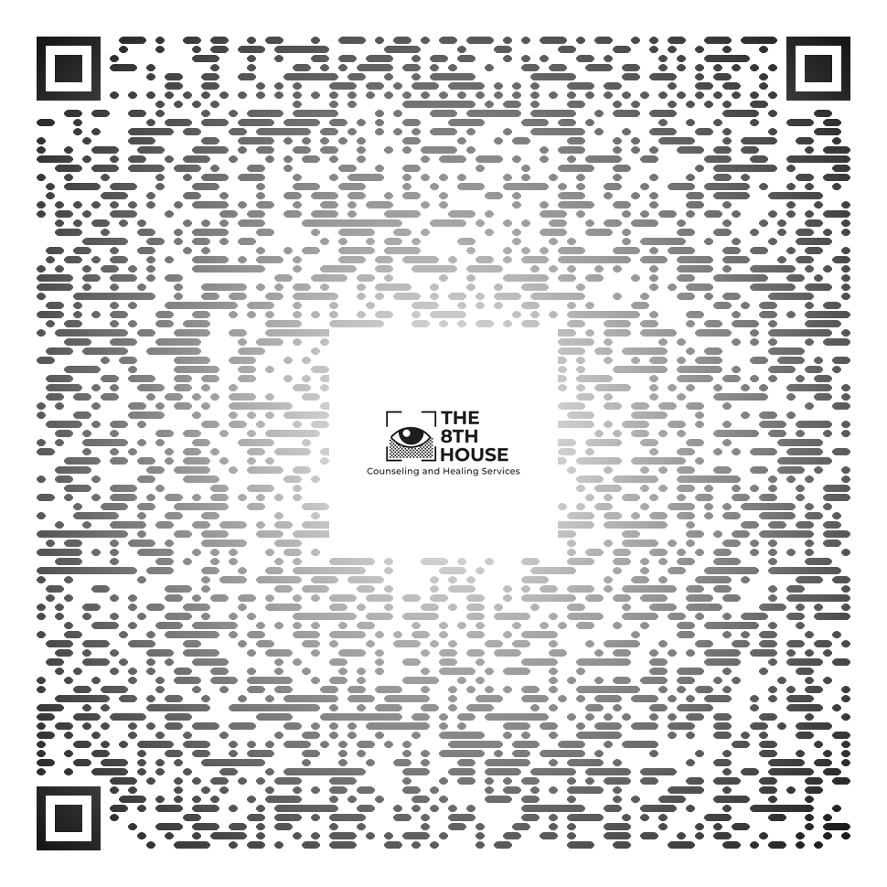 |  | Educational Goals  Financial Goals  - Donate to charity  - Volunteer at a hospital  - Learn new job skill  - Complete project  - Get promotion  - New job  - Investment Account  - Save certain amount  - Get a raise  - Get out of debt  Career Goals  Career Goals  - Earn credits towards degree  - Learn new skill  - Join health club  - Set doctor appointment  - Relax more  - Plan a trip  - Read a book  Aim For Greater Self- Understanding  Community Involvement  - Start new hobby  - Attend sports event  - Self care routine  Leisure Time  - Attend a house of worship  - Meditate/Pray  Health and Fitness Goals  - Quit Smoking  - Eat nutritious food  - Journaling  - Ancestry Kit Profile  - Therapy Services  - Meet new people  Spiritual Growth

